import pandas as pd # Core libraries
import numpy as np
import matplotlib.pyplot as plt # Visualization tools
import seaborn as sns
from sklearn.preprocessing import StandardScaler # Preprocessing utilities
from sklearn.impute import SimpleImputer
from sklearn.cluster import KMeans, DBSCAN # Clustering algorithms
from sklearn.metrics import silhouette_score, davies_bouldin_score # Evaluation metrics
from sklearn.decomposition import PCA # Dimensionality reduction
import io # Miscellaneous

# Load the dataset
file_path = "Fragrance Dataset - COM7022 - [4037].csv"
df = pd.read_csv(file_path)

# Select the columns to be used for clustering
selected_cols = ['price', 'available', 'sold']
data_subset = df[selected_cols].copy()

# Handle missing values using median replacement
median_filler = SimpleImputer(strategy='median')
data_filled = pd.DataFrame(
median_filler.fit_transform(data_subset),
columns=selected_cols
)
# Normalize the features
scaler = StandardScaler()
scaled_data = scaler.fit_transform(data_filled)

print("Data successfully cleaned, imputed, and normalized.")

print(" 2. Executing K-Means Elbow Analysis ")

# --- Compute WCSS for a range of k values ---
inertia_values = []
candidate_k = range(1, 11)

for num_clusters in candidate_k:
km_model = KMeans(
n_clusters=num_clusters,
init="k-means++",
n_init=10,
random_state=42
)
km_model.fit(scaled_data)
inertia_values.append(km_model.inertia_)

# --- Plot the elbow curve ---
plt.figure(figsize=(10, 6))
plt.plot(candidate_k, inertia_values, marker='o', linestyle='--')
plt.title("Elbow Curve for Determining Optimal k")
plt.xlabel("Cluster Count (k)")
plt.ylabel("Within-Cluster Sum of Squares (WCSS)")
plt.grid(True)
plt.xticks(candidate_k)

# --- Save elbow plot ---
elbow_output = "kmeans_elbow_plot.png"
plt.savefig(elbow_output)
print(f"Elbow method plot saved at: {elbow_output}")

# --- Apply K-Means using a selected k value ---
chosen_k = 6
final_kmeans = KMeans(
n_clusters=chosen_k,
init="k-means++",
n_init=10,
random_state=42
)
kmeans_cluster_labels = final_kmeans.fit_predict(scaled_data)

print(f"\nK-Means clustering completed with k = {chosen_k}")

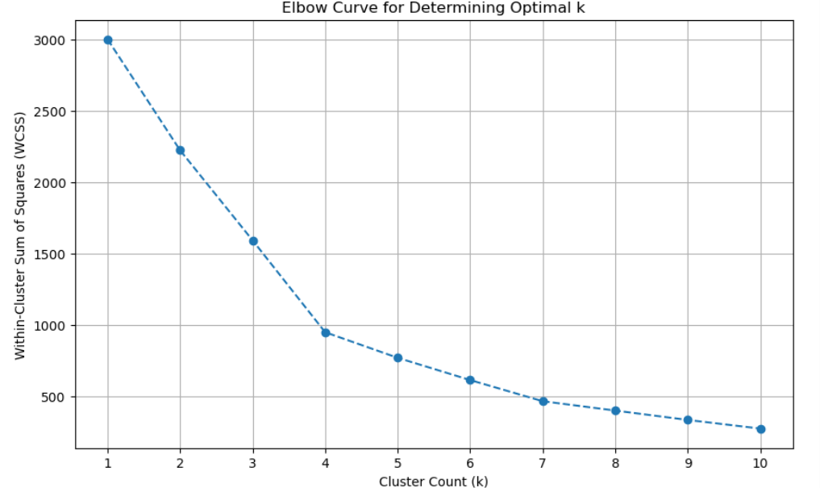

try:
# --- DBSCAN hyperparameters ---
eps_val = 0.7
min_pts = 6

# --- Run DBSCAN on the scaled dataset ---
dbscan_model = DBSCAN(eps=eps_val, min_samples=min_pts)
dbscan_assignments = dbscan_model.fit_predict(scaled_data)

# --- Reduce dimensionality with PCA for visualization ---
pca_model = PCA(n_components=2)
pca_results = pca_model.fit_transform(scaled_data)

# --- Build a DataFrame for plotting ---
pca_frame = pd.DataFrame(pca_results, columns=["PC1", "PC2"])
pca_frame["cluster_id"] = dbscan_assignments

# --- Prepare the scatter plot ---
plt.figure(figsize=(10, 7))

labels_present = sorted(set(dbscan_assignments))
num_clusters = sum(1 for lbl in labels_present if lbl != -1)

valid_cluster_labels = [lbl for lbl in labels_present if lbl != -1]

if num_clusters > 0:
color_list = [plt.cm.viridis(pos) for pos in np.linspace(0, 1, num_clusters)]
else:
color_list = []

color_map = {-1: (0.1, 0.1, 0.1, 1.0)} # noise color
color_map.update({lbl: col for lbl, col in zip(valid_cluster_labels, color_list)})

sns.scatterplot(
x="PC1",
y="PC2",
data=pca_frame,
hue="cluster_id",
palette=color_map,
s=50,
alpha=0.7
)

plt.title(f"DBSCAN Clustering (eps={eps_val}, min_samples={min_pts}) - PCA Projection")
plt.xlabel("Principal Component 1")
plt.ylabel("Principal Component 2")

# --- Customize legend labels ---
handles, label_texts = plt.gca().get_legend_handles_labels()
revised_labels = ["Noise" if lbl == "-1" else f"Cluster {lbl}" for lbl in label_texts]
plt.legend(handles=handles, labels=revised_labels, title="dbscan Cluster")

plt.grid(True)

output_path = "dbscan_cluster_plot.png"
plt.savefig(output_path)
print(f"DBSCAN cluster plot saved to: {output_path}")

except Exception as err:
print(f"An error occurred: {err}") 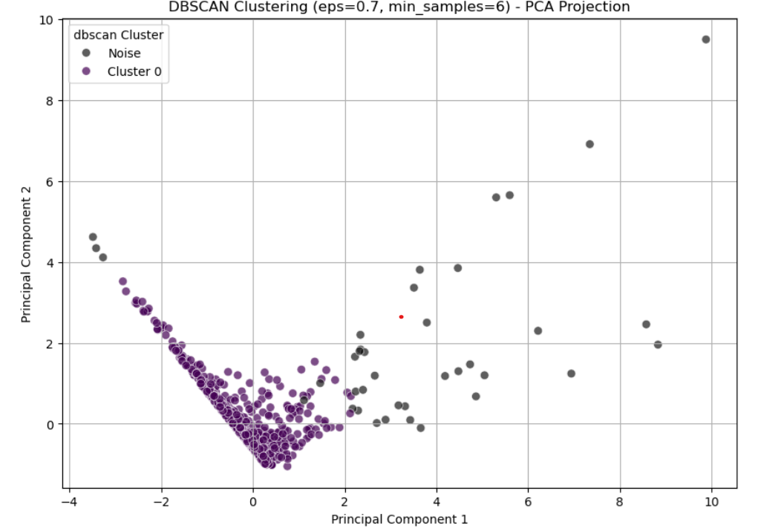

silhouette_avg = silhouette_score(scaled_data, kmeans_cluster_labels)
print(f"Clustering Performance Metric - Silhouette Score (k=5): {silhouette_avg:.5f}")
print("---") # Alternative separator
db_index = davies_bouldin_score(scaled_data, kmeans_cluster_labels)

print(f"Separation Metric - Davies-Bouldin Index (k=5): {db_index:.5f}")
